CE301 Individual Capstone Project dp19963

**Goals until the next meeting:**

Until my fourth meeting with my supervisor I did the following, I added buttons to the homepage like you saw in the front page and when you hover above the buttons they will change colour.

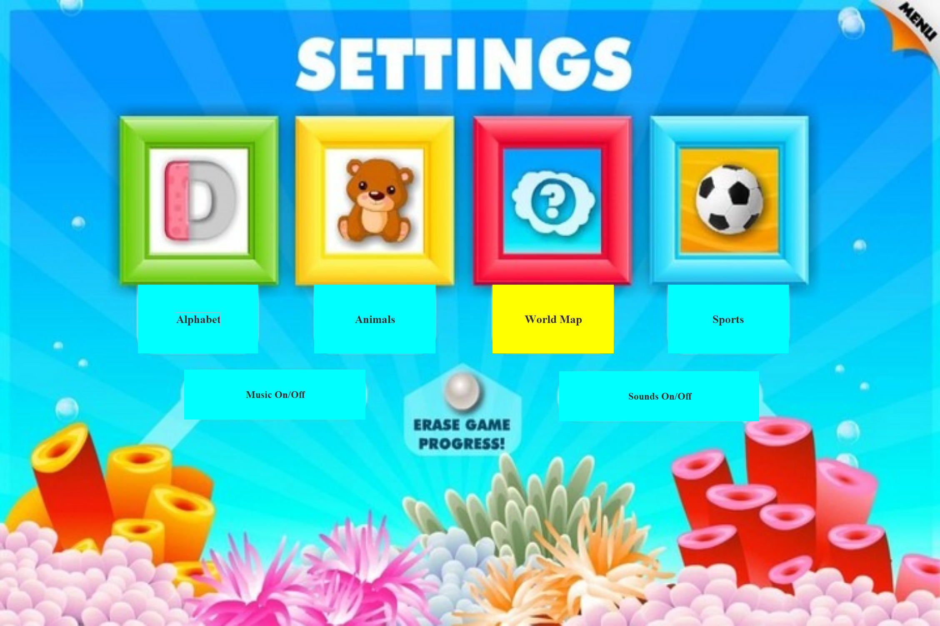

I also added music to the software that will run in the background. It’s not really functioning the way I want it to just yet but there’s commands in the console log as you can see.

I will add the same type of functionality to the two buttons in the home page (Music/Sound off/on).